17.1.2 Editors - Graph Editor - View Menu
Dopesheet Editor - View Menu 1
Sidebar 1
Adjust last Operation 2
Set Preview Range 2
Clear Preview Range 2
Auto Set Preview Range 2
Zoom In 2
Zoom Out 2
Zoom Border 2
Frame All 2
Frame Selected 3
Go to current Frame 3
Area 3
Horizontal Split 3
Vertical Split 3
Duplicate Area into New Window 3
Toggle Maximize Area 3
Toggle Full screen Area 3
Pie menus 3

Dopesheet Editor - View Menu

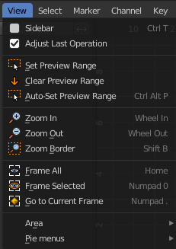
The View menu contains all View related tools.

The content is for all modes the same.

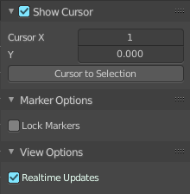
Sidebar
Shows or hides the sidebar at the right in the viewport.

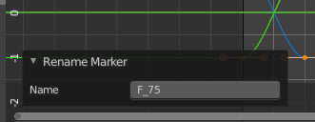
Adjust last Operation
Show the Adjust Last Operation panel down left when you perform a tool.

Set Preview Range
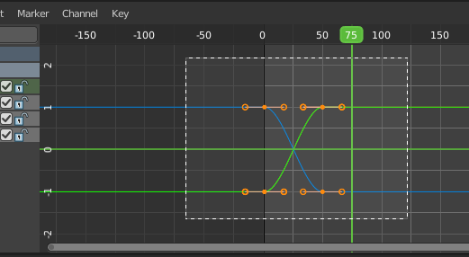
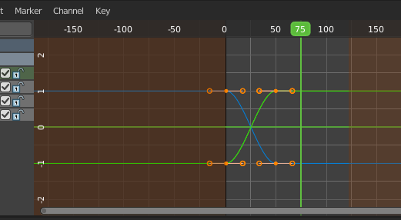
Rectangle select an area of the timeline that gets previewed. The playback now just happens in this marked area.

Clear Preview Range
Clears an existing preview range.

Auto Set Preview Range
Sets the preview range between the first and last keyframe of the animation.

Zoom In
Zooms into the viewport.

Zoom Out
Zooms out of the viewport.

Zoom Border
Draws a rectangle and zooms then to fit the size of this rectangle.
Zooming in is done with drawing the rectangle with left mouse button. Zooming out is done with drawing the rectangle with middle mouse button.

Frame All
Zooms in or out in the viewport until all objects in the scene are displayed fitting in the viewport.

Frame Selected
Centers the view at the currently selected keyframe(s).

Go to current Frame
Centers the view at the frame slider.


Area
This menu contains general view functionality. And exists in most other editor types too.

Horizontal Split
Splits the current view horizontally into two independent editor windows.

Vertical Split
Splits the current view vertically into two independent editor windows.


Duplicate Area into New Window
Duplicate Area into New Window makes the selected editor window floating. You can then drag it around at the monitor. It is not connected with the rest of the UI anymore.
A separated window cannot be merged into the main window again. You have to close it when not longer needed.

Toggle Maximize Area
Displays the editor maximized with menus.
To return from the maximized view press hotkey ctrl + spacebar. Or reuse the menu item in the area menu.

Toggle Full screen Area
Displays the editor maximized without menus.
To return from the full screen view press hotkey ctrl + alt + spacebar.

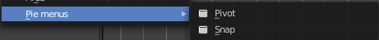
Pie menus
Lists the available pie menus, and gives you the ability to read the hotkeys and assign own hotkeys.

